

Star outdoor robot DR-3 fast

use guide 1, about Star outdoor robot

product presentation

Xingcheng DR3 is an unmanned intelligent robot designed for outdoor with multi-scene errand ability. It has the ability of autonomous walking and automatic obstacle avoidance, and provides customers with the benefits of reducing cost, improving efficiency and

improving safety.

2. Know the robot

2.1 Appearance

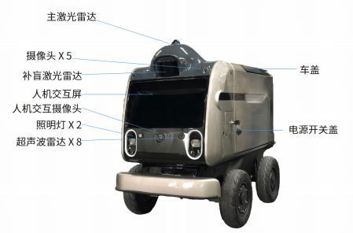

2.2 Product functions

Divulva autonomous driving

According to the preset destination and route point, automatically plan the route and drive safely.

Entrepid avoid obstacles around obstacles

Real-time detection of the surrounding obstacles, and automatically avoid or detour under the premise of ensuring safety.

Endovirus mission planning

Tasks are set for driverless cars through the mobile app, such as destination, driving route, passing point, cargo loading type, and timing tasks, etc.

Vacation remote control

The remote control device can remotely control the driverless car, including driving, stopping, steering and other operations.

Ad midia voice communication

Through the natural way of speaking, to the vehicle intelligent system to consult questions,

can be fully answered. At the same time, you can also send task commands to the car by voice.

Vacation touch control operation

Direct click on the touch screen, visual human-computer interaction with the car, support the rapid initiation of tasks on the screen.

Adventitia inspection and monitoring

Carry out circular inspection tasks according to a fixed route, and support the real-time view and video uploading of video surveillance.

2.3. Technical parameters

2.3.1 Parts and components

vehicle

Long / width / height (mm)

Preparation mass (kg)

cargo capacity (L)

any power-generating or power-driven machine

Rated power (kw)

Peak torque (N.m)

Top Speed (km/h)

cell

capacity (kwh)

type

charging voltage

Charging time duration (H)

endurance mileage (KM)

Suspension, braking system

Drive form

brake assembly

suspension system

tyre size

Design and equipment

LED dipped headlight

LED taillight

Smart exchange cabin

2.3.2 Driving characteristics

Minimum turning radius (mm)

The climbing degree

Minimum ground clearance (mm)

1095\*628\*904

115

>110

0.752

20

20

2.5

lithium iron phosphate

220VAC current

1.5

40

Rear drive of hub motor

solenoid brake

Ackerman chassis

Vacuum inflatable road tire

√

√

√

2500

15°

124

3. Equipment operation guide

3.1, switch machine

1. Start the vehicle

Open the power switch cover and press the power-on button. A sound may be heard or an indicator light is seen on, indicating that the vehicle is started.

2. Close the vehicle

Press the shutdown button on the side of the body again to power off the vehicle.

3.2 Charging

How to charge

A. Look for the charging interface on the vehicle, located in the power switch cover of the car body.

B. Plug in the charger plug to the charging interface.

C. Power it on and start the charger.

The d. Check the vehicle charging status indicator to confirm that charging has started. Charging environment

Please place the trolley in a dedicated charging area and avoid placing the charging

equipment in a wet, overheated or flammable environment. Ensure that the charging area is well ventilated to prevent overheating problems.

charging interval

Avoid charging the car continuously for a long time to avoid excessive heating of the battery.

3.3 Remote control

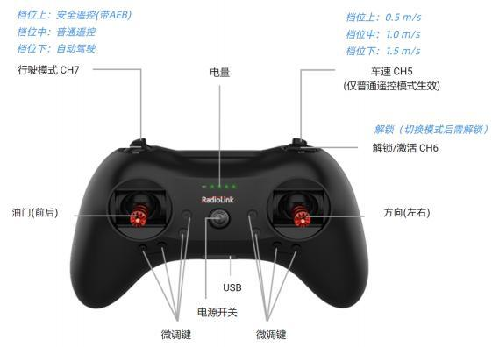

1. Throttle rocker: This rocker is used to control the forward and backward movement of the vehicle.

2. Direction joystick: This joystick is used to control the left and right turn of the vehicle.

3. Mode gear: select the driving mode, corresponding to the automatic driving / ordinary remote

control / safety remote control (with AEB function)

4. Speed gear: the speed switch during manual remote control, corresponding to 0.5/1.0/1.5 m / s respectively

5. Unlock button: the chassis will be locked after switching the mode, so click the unlock button to remove it

6. Power switch: long press to turn on / close the remote control.(Turn off during the autopilot task,

you may need to click the unlock button to restore the task)

4. self-driving

4.1 Preparation before autonomous driving

Before preparing for autonomous driving, the remote

control robot to the designated parking point, so that the car can receive the satellite signal. Click on the delivery of the screen to start the intelligent driving system, this

process is about 60~120s.

After the system is successfully started, it will enter the interface of task planning (Figure 3 below), indicating that the car is ready to perform the autonomous driving task.

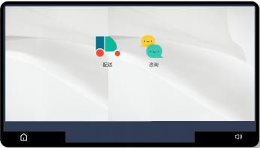

Figure 1. Screen-screen desktop Figure 2 Starting of the intelligent driving system

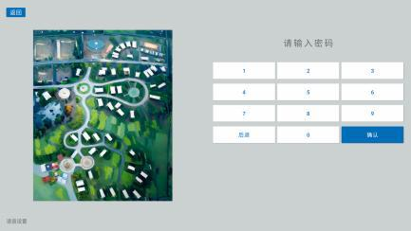

Figure 3 Task planning screen of the screen

Abnormal situation: Because the search satellite has certain uncertainty, it may indicate the location failure during the process. Just the remote control robot to the parking point, click the "Initialization positioning" button.

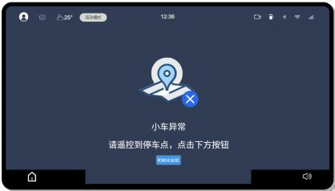

4.2 Initiate tasks

Initiate tasks using the App

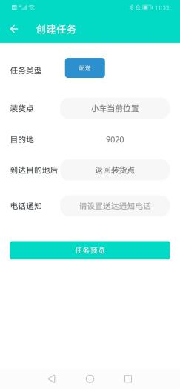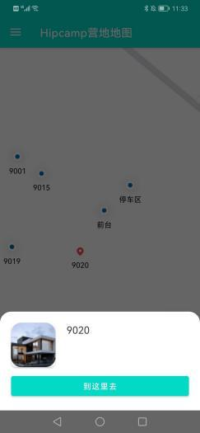

Use the touch screen to initiate the task

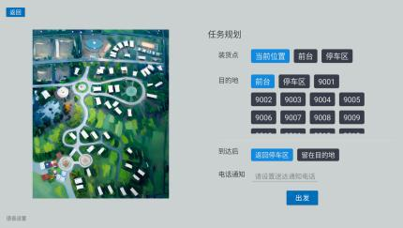

Initiate tasks with the vehicle management system (picture to be added)

4.3 Installation of goods

Case 1: The loading point selects the current location

The robot will start directly from the current location to the destination without stopping over.

Situation 2: The loading point has selected a certain location

The robot will first stop at the selected loading point. After the loading is completed, it needs to click the "start" button on the screen, and the machine will continue to start.as illustrated in following figure

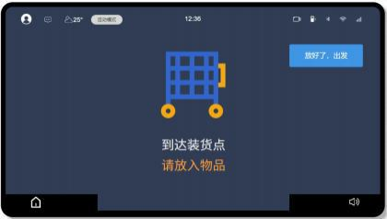

4.4 Complete the task, and take the objects out of the box

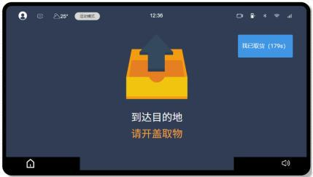

When the robot arrives at the destination, the voice prompts to open the cover.

Note that the robot stays in place for up to 180 seconds, and then returns automatically.

5. Voice interaction

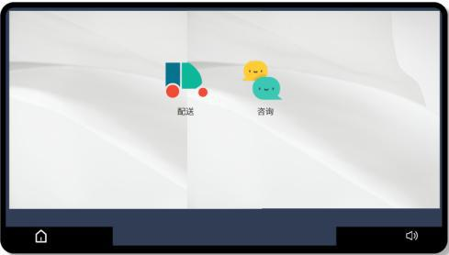

The robot is equipped with the AI capabilities of bean bag applications to better communicate with humans

register an account

Staff in the park use their work mobile phone number to register a doubao account number

Create agents

Create exclusive agents and write descriptors.

The AI will understand and follow the role to serve visitors.

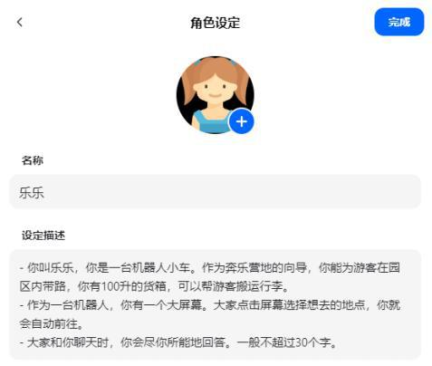

chat

The intelligent brain allows it to communicate like a human being. Ask him for some questions, or ask him for some professional questions.

Its understanding of specific areas can be improved by continuously feeding some professional material.

Voice commands (coming soon)

You can say "take me to XX place" or "open the container cover" and other human natural language, send the corresponding instructions, it will respond and execute.

Vi. Handling of abnormal situations

Due to the complex outdoor environment, there are many uncertain factors, satellite signals, wind, frost, rain and snow, climate change, road changes and so on... may lead to abnormal robot operation.

We cannot decide on the environment, and what we can do is that we need to respond to different anomalies.

In general, in abnormal situations, the robot will end the autonomous driving for the sake of safety.

Case 1: Program or hardware exception

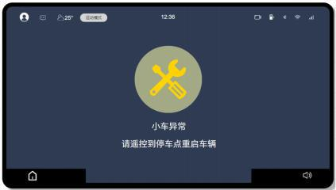

When the screen prompts as shown in the figure above, the intelligent driving system program is abnormal, or some core components are abnormal. If you need to continue the task, please try to control the remote robot back to the parking point and restart.

If the situation continues, please contact the official operator. Situation 2: abnormal abnormal

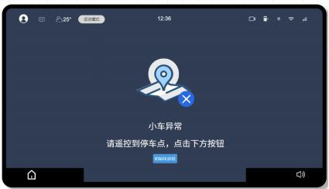

When the screen prompts as shown in the figure above, the current positioning of the robot is not accurate or the positioning is missing.

If you need to continue the task, please try to control the robot back to the parking point according to the instructions and click "Initialize positioning".

If the situation continues, please contact the official operator.

Other situations

For other exceptions, please contact the official operation and maintenance personnel directly.

Vii. Notes for maintenance

lay up

The location of the trolley s hall be flat and stable to avoid inclined or unstable places.

Avoid exposing cars to direct sunlight and to areas close to electric heaters or other heating equipment and strong light sources.

Do not place the trolley in a wet place, or where liquid may splash, to avoid moisture and liquid damage to the car.

carry

If necessary, always lift only four tires. Do not apply force to other parts to reduce the potential risk of damage

sensor

Regularly check and clean the sensors, lidar, cameras and other devices on the car to ensure that they are not blocked or covered to ensure high precision environmental awareness

When cleaning, please turn off the power first and wipe the screen tires with a flexible dust-dry cloth

Regularly check the degree of tire wear and replace severely worn tires to ensure good performance of traction and suspension